1.To check the given number is palindrome or not.

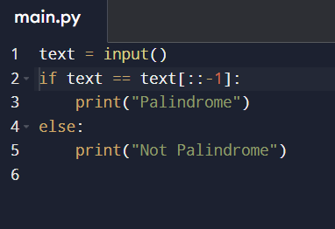

2.to check the given number is Armstrong or not.

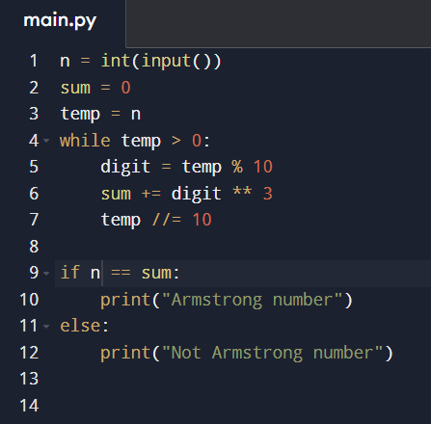

3. write a program program to reverse a string.

